**Project Design Phase-II**

**Data flow diagrams and user stories**

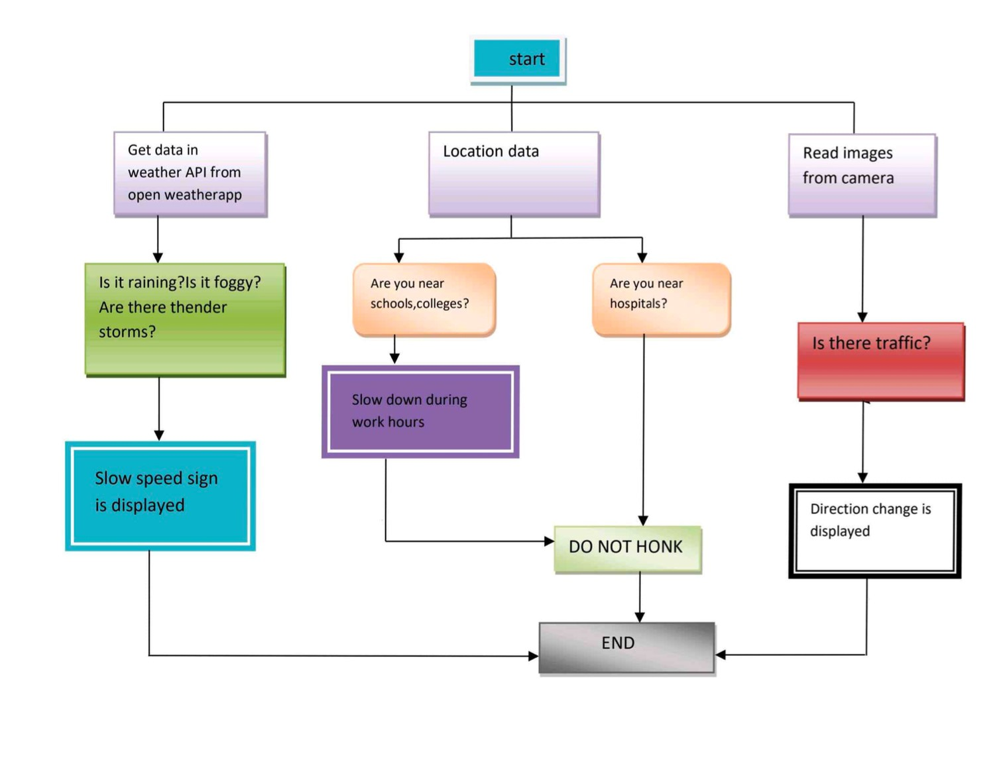

|  |  |
| --- | --- |
| **Date** | 14.10.2022 |
| **Team ID** | PNT2022TMID41963 |
| **Title** | Signs with Smart Connectivity for Better Road Safety |

**Data Flow Diagram:**

**User Stories:**

